## PROBLEM

### **CSS - EXTERNAL STYLING BY ID**

**CSS - external styling by id**

Webnotch Technologies is an emerging web application development company. Established by a group of highly knowledgable software enthusiasts with great vision, the company has indispensable knowledge in web design development, Info-graphics, etc.,  
  
Mahepal, the founder of Webnotch Technologies signed up a deal with Pink Frag Event Organizer for creating a webpage for establishing their deemed services. The company's web designer Kissan is innovative in making colorful blogs and was assigned this task for Pink Frag Client. The major constraint of the task is that, the blog should be colorful with contents and innovative with informations. So create a webpage by using the external styling method using id element by accomlishing the task assigned to Kissan.

**Hints :**

**#id selector**

The id selector uses the id attribute of an HTML element to select a specific element.

The id of an element should be unique within a page, so the id selector is used to select one unique element

Syntax :

 external styling

#id {

css declarations;

}

**Content :**  
H1 - Pink Frag Event Organizer  
HR  
H2 - Service Description  
P - We are indulged in offering a Promotional Event Management. These services are provided by our team of professionals as per the requirement of the client. These services are highly praised for their features like sophisticated technology, effective results and reliability. We offer these services in a definite time frame and at affordable rates.  
HR  
H2 - Features  
H5 - Customized services  
H5 - On-time completion  
H5 - Execution in tandem with clients demand  
HR  
H2 - About Us  
p- M. S. Event is a reputed organization, which has come into being in 2009, as a Sole Proprietorship Firm, with a sole aim of achieving the trust and support of large customers. We have indulged our all endeavors towards offering trustworthy Wedding Event Management, Promotional Event Management, Birthday Party Management and many more. All our services are reliable and offered keeping the exact customers’ preferences and choice in mind. To offer these services, we have hired specialized professionals, who are capable of understanding as well as accomplishing the specific customers’ desires.  
 <br>  
We have adopted modern technology, to cope up with the challenges of industry. We keep all quality parameters in mind, so that we cannot make any compromise in terms of the excellence of products.  
HR  
<br>  
<br>  
<br>  
<br>  
 H2 - Contact Us  
 H3 - Address  
 p - 14/509A,Sterlin Street,Nungambakkam Chennai - 600034.  
 H3 - Mobile  
 p - Manager-9596645125  
 H3 - Landline  
 p - 0422-2727272  
 H3 - EMail  
 p - pinkfragevent123@gmail.com pinkfragOfficial@gmail.com  
  
h1 titles are in pink color(#F835C0)  
h2 titles are in red color(#ff0000)  
h3 titles are in green color(#15D365)  
h5 titles are in violet color( #9F41F5)  
  
**Constraints :**  
The webpage design should be of internal style.  
The content given in the template should not be changed.  
The colors should be same as given in the content.  
Use id attribute for styling the webpage.  
  
**Note :**  
Content of the page should be present as shown in the screenshot.  
Kindly refer the content which is given as a part of description  
  
**Sample Screenshot 1 :**  
  
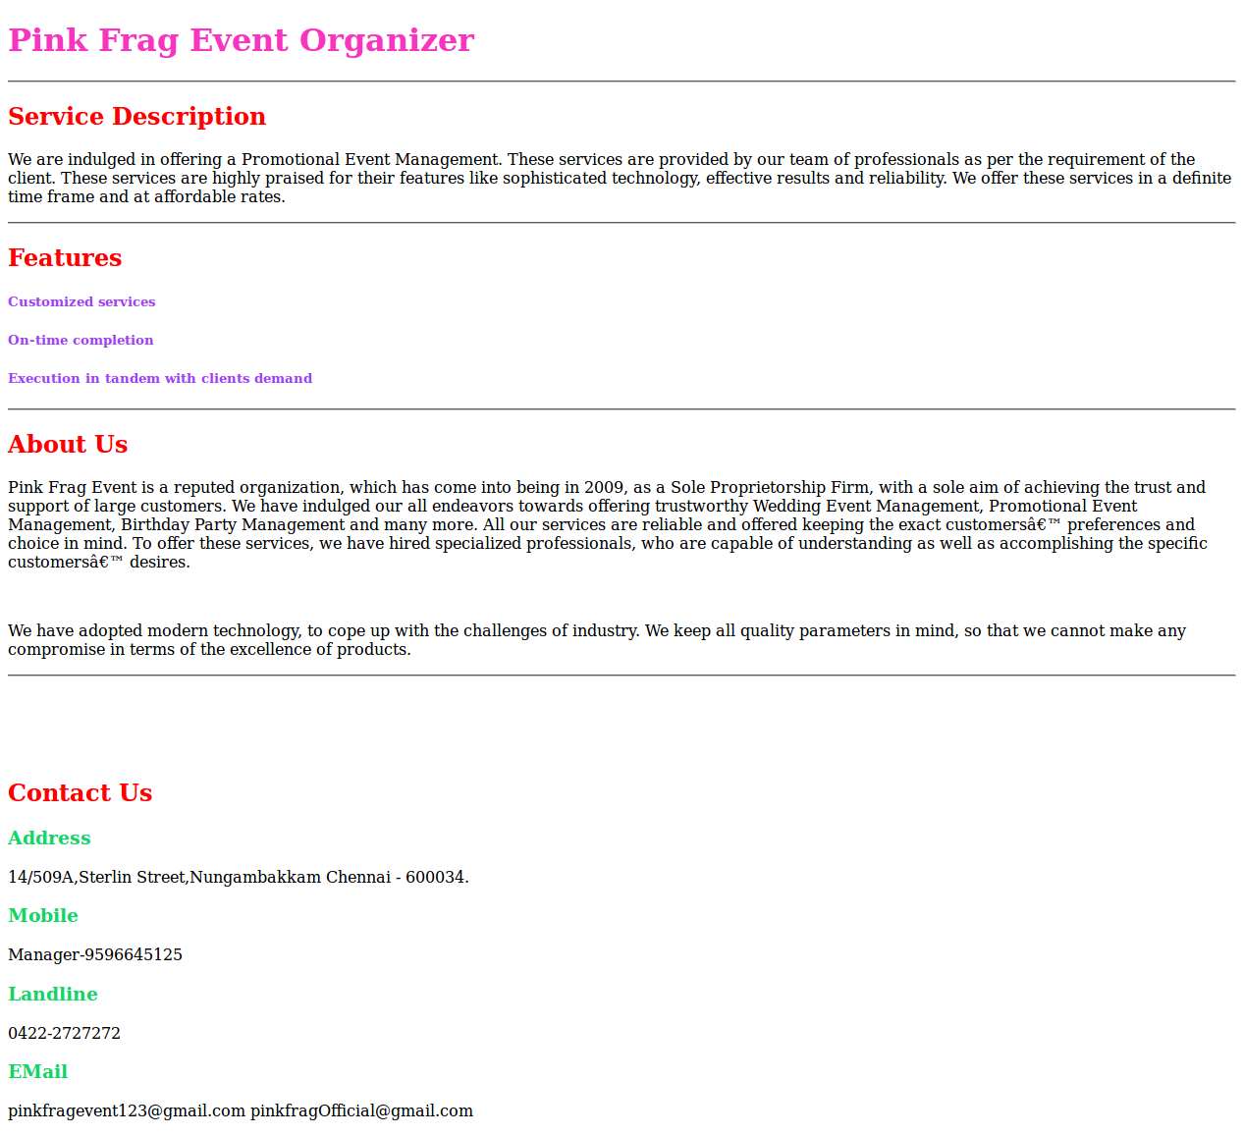  
  
**Sample Screenshot 2 :**  
  
